**PROJECT REPORT**

**NAME: JOHN JOSHUA JUNIOR**

**MATRIC: 130407018**

**COURSE TITLE: AUTOMATED REASONING**

**COURSE CODE: SSG 504**

**EXPERT SYSTEM**

**LAUREL: A LAPTOP DIAGNOSTICS EXPERT**

**(GROUP ONE)**

**ABSTRACT**

Fault diagnosis is very important in the field of computer engineering and information technology, especially in personal computer (PC) troubleshooting. Today, the use of computers is widespread; however, the knowledge in computer troubleshooting is limited, and this poses difficulties among organizations when faced with computer problems. The expert system ‘LAUREL’ was developed to assist and advise new technicians or computer users in the diagnosis and troubleshooting of their Personal Computers.

**INTRODUCTION**

Fault diagnosis in technical systems has received a lot of theoretical and practical attention over the last years. Diagnosis is a complex reasoning activity, which is currently one of the domains where Artificial Intelligence techniques have been successfully applied as these techniques use association rules, reasoning and decision making processes as would the human brain in solving diagnostic problems.

Computers are machines and the more we rely on them the more vulnerable we find ourselves when they fail. The consequences are damage to important data, waste of resources and frustration. According to Ikekeonwu[1], before one can use a computer, the computer must be operating. One sets the computer operating by starting (or booting) it. Many things can obstruct the operation and performance of the computer. Troubleshooting and diagnosing a computer system is a knowledge-intensive task. Depending on the experience of the user, a simple problem could take hours or even days to solve. An Expert System offers a viable solution to the problem. According to Pomykalski, Truszkowski and Brown [2], an Expert System is a computer program that is designed to imitate the decision-making ability of a decision maker in a particular narrow field of expert knowledge or skill.

An expert system is a computer system that emulates the decision-making ability of a human expert. Expert systems are designed to solve complex problems by reasoning through bodies of knowledge, represented mainly as if–then rules rather than through conventional procedural code.

Expert systems found broad application in fault diagnosis from their early stages because an expert system simulates human reasoning about a problem domain, performs reasoning over representations of human knowledge and solves problems using heuristic knowledge rather than precisely formulated relationships, in forms that reflect more accurately the nature of most human knowledge.

**2.0 THE LAPTOP DIAGNOSTICS EXPERT (LAUREL)**

The Laptop Diagnostics Expert System, like any other knowledge based expert system consists of the knowledge-base, the inference engine, the explanation facility system, and the user interface. The architecture presented below show the cycle of activities and interaction in the development of the PC faults troubleshooting system

Laurel is a Rule-Based Diagnostic Expert Systems: Rule-based expert systems have a wide range of applications for diagnostic tasks where expertise and experience are available but deep understanding of the physical properties of the system is either unavailable or too costly to obtain. In the rule-based systems, knowledge is represented in the form of production rules. A rule describes the action that should be taken if a symptom is observed. The empirical association between premises and conclusions in the knowledge base is their main characteristic. These associations describe cause effect relationships to determine logical event chains that were used to represent the propagation of complex phenomena. The general architecture of these systems includes domain independent components such as the rule representation, the inference engine and the explanation system. Basic structure of a classical rule-based expert system is presented below.

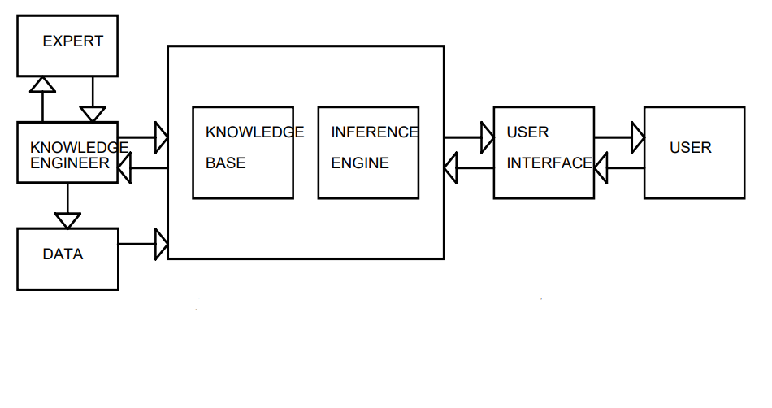

**3.0 METHODOLOGY**

The design model adopted in this rule based system as shown in the table below.

|  |  |
| --- | --- |
| **IF** | **THEN** |
| If computer starts up makes one short beep | Drive not detected |
| Start up 1 short beep and 1 long beep | Memory problem |
| Start up 3 short beep and 1 long beep | CPU configuration error/CPU type not compatible |
| Start up,2 short beep and 1 long beep | Video card required but not installed |
| Appears to start up but battery power Led continuously glow | Battery charging but not sufficient to power the notebook |
| Appears to start up but caps lock led blinks once | CPU not functional |
| Appears to start up butcaos lock led blinks twice | BIOS corruption failure |
| Appears to start up but caps lock led blinks thrice | Mebght52qYA$zdxfuicopolfmhn gv mory, module error not functional |
| Appears to start up but caps lock led blinks 4 times | Graphics controller not functional |
| Appears to start up but caps lock led blinks 5 times | Motherboard failure |
| Battery doesn't accept charge and power ON PC without ac adapter | Battery is faulty or not supported |
| LED blinks,attempts to power on but failed | Check hard disk or ram |
| Power button LED blinks 5times with 5beeps | Ram or system board failure |
| Power button LED blinks 6 times with 6 beeps | Video card or graphics might be faulty |
| Power button LED blinks 7 times with 7 beeps | Motherboard failure |
| Power button LED blinks 8 times with 8 beeps. | BIOS or CMOS problem ( perform bios recovery with external media) |
| System crashes and shows blue screen |  |
| Applications running slowly | Hardware failure or driver malfunctioning |
| Computer is noisy | Processing power or memory is running low |
| Computer overheating | Fan is dirty or old |
| PC on but blank display | Fan might not be working or system has been overworked |
| Keyboard not typing | Monitor is bad or graphics is bad |
| Computer crashes before windows load | Driver issue or keyboard is bad |

**4.0 IMPLEMENTATION**

The expert system is implemented using Prolog Programming Language. Prolog is a general-purpose logic programming language associated with artificial intelligence and computational linguistics

The choice of the programming language was as a result of features supported by the language. Prolog is a powerful programming language, it is portable, robust, multi-platform enabled and simple.

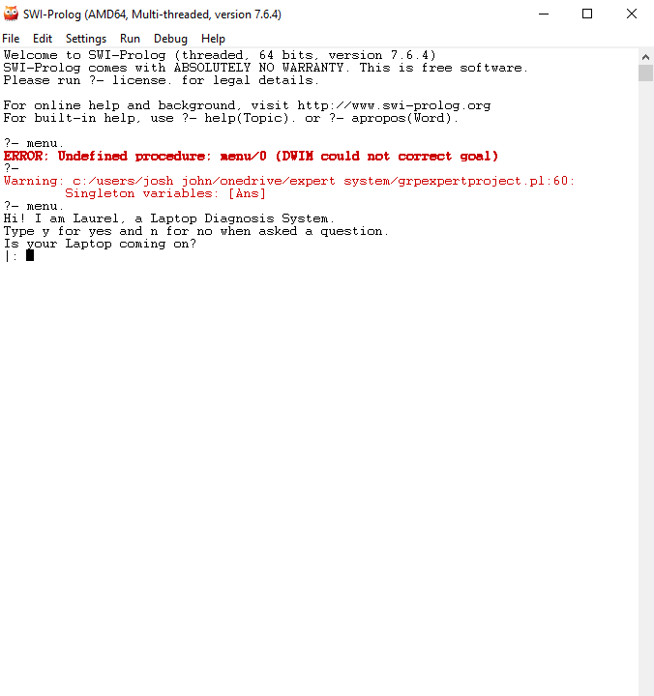

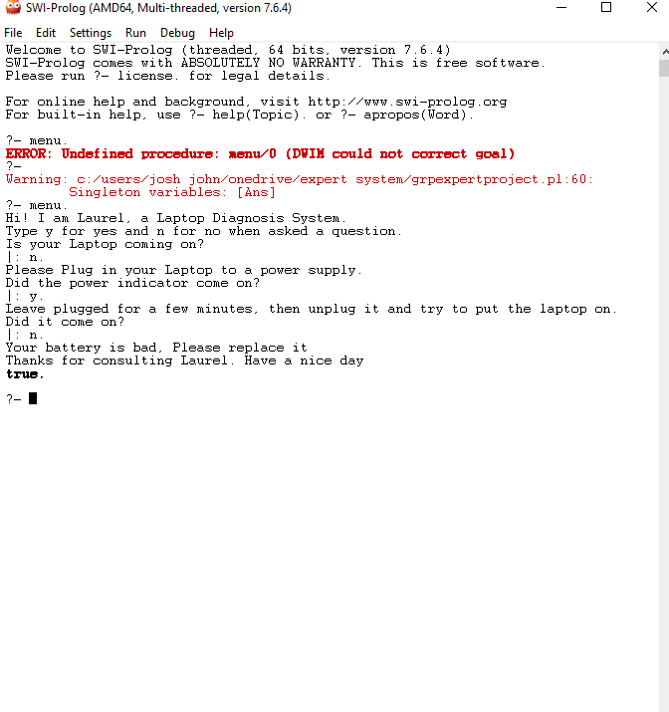

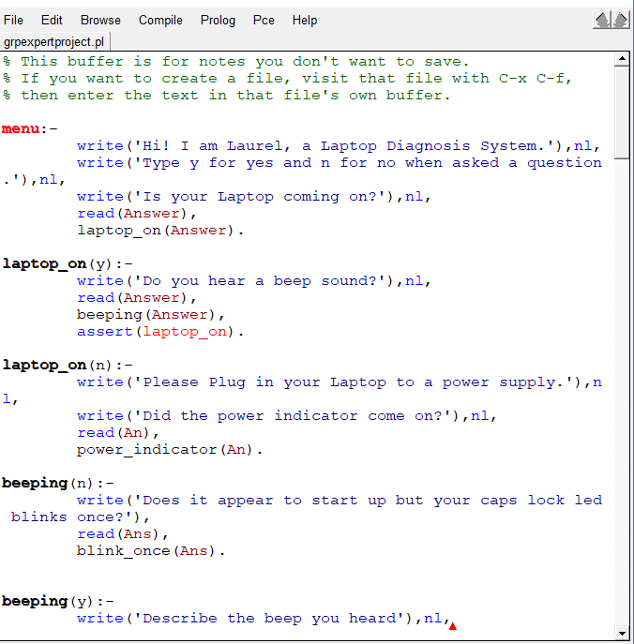

**REFERENCES**

[1] Ikekeonwu, G.A.M.(2003) “Computer Applications”, Immaculate Publication Limited, Enugu, Nigeria. [2] Pomykalski, J. J., Truszkowski, W. F. & Brown, D. E.(1999) “Expert System”, In The WileyEncyclopedia for Electrical and Electronics Engineering (edited by J. Webster), February, 1999. [3] Kaushik, A., Satvika, B. & Manoj, B. (2012), “Printer Troubleshooting Expert System”, In the International Journal of Advanced Research in Computer Science and Software Engineering, Vol. 2 (10).

**APPENDIX**

% Laurel, The Laptop Diagnostics Expert System

menu:-

write('Hi! I am Laurel, a Laptop Diagnosis System.'),nl,

write('Type y for yes and n for no when asked a question.'),nl,

write('Is your Laptop coming on?'),nl,

read(Answer),

laptop_on(Answer).

laptop_on(y):-

write('Do you hear a beep sound?'),nl,

read(Answer),

beeping(Answer),

assert(laptop_on).

laptop_on(n):-

write('Please Plug in your Laptop to a power supply.'),nl,

write('Did the power indicator come on?'),nl,

read(An),

power_indicator(An).

beeping(n):-

write('Does it appear to start up but your caps lock led blinks once?'),

read(Ans),

blink_once(Ans).

beeping(y):-

write('Describe the beep you heard'),nl,

write('for one short beep'),nl,

write('reply a'),nl,

write('for one short beep and one long beep'),nl,

write('reply b'),nl,

write('for two short beeps and one long beep'),nl,

write('reply c'),nl,

write('for three short beeps and one long beep'),nl,

write('reply d'),nl,

write('Reply with "e" if beep description is not listed'),nl,

read(Ans),

beep_type(Ans).

beep_type(a):-

write('Your laptop cannot detect the CD Drive'),nl,

assert(beep_type).

beep_type(b):-

write('The RAM of your laptop is damaged or not properly placed'),nl,

assert(beep_type).

beep_type(c):-

write('Video card not installed, Get a Video Card'),nl,

assert(beep_type).

beep_type(d):-

write('The installed CPU type is not compatible'),

assert(beep_type).

beep_type(e):-

blink_once(Ans).

blink_once(y):-

write('Your CPU is not functional'),nl,

end.

blink_once(n):-

write('Did your laptop appear to start up but you caps lock led blinks twice?'),

read(Ans),

blink_twice(Ans).

blink_twice(y):-

write('BIOS corruption failure'),

end.

blink_twice(n):-

write('Or maybe it tried to start up but your caps lock blinks three times?'),

read(Ans),

blink_three_times(Ans).

blink_three_times(y):-

write('Memory, module error not functional'),nl,

end.

blink_three_times(n):-

write('Was it four times then?'),

read(Ans),

blink_four_times(Ans).

blink_four_times(y):-

write('Your graphics controller is not functional'),

end.

blink_four_times(n):-

write('One more question on blinking, did your caps lock indicator blink five times instead?'),

read(Ans),

blink_five_times(Ans).

blink_five_times(y):-

write('You might want to sit down for this one'),nl,

write('So the issue is with your Motherboard. She has failed'),nl,

end.

blink_five_times(n):-

write('Maybe it is the power button LED'),nl,

write('Did it blink then attempts to power on but failed?'),

read(Ans),

power_blink(Ans).

power_blink(y):-

write('Check your hard disk or RAM card'),nl,

write('They may have dislodged').

power_blink(n):-

write('Hmmmmm'),nl,

write('Did it blink 5 times while beeping 5 times too?'),

read(Ans),

blink_5_beep_5(Ans).

blink_5_beep_5(y):-

write('RAM or mother board failure!'),

nl,end.

blink_5_beep_5(n):-

write('Was it 6 times apiece?'),

read(Ans),

blink_6_beep_6(Ans).

blink_6_beep_6(y):-

write('Video or graphics card might be faulty'),nl,

end.

blink_6_beep_6(n):-

write('Seven?'),

read(Ans),

blink_7_beep_7(Ans).

blink_7_beep_7(y):-

write('Motherboard failure').

blink_7_beep_7(n):-

write('Eight maybe?'),

read(Ans),

blink_8_beep_8(Ans).

blink_8_beep_8(y):-

write('BIOS or CMOS problem'),nl,

write('Perform BIOS recovery with external media').

blink_8_beep_8(n):-

write('Did your laptop boot normally?'),

read(Ans),

normal_boot(Ans).

normal_boot(y):-

write('Thank goodness'),nl,

end.

normal_boot(n):-

write('Did your laptop crash before your OS loaded?'),

read(Ans),

assert(normal_boot(n)),

os_corrupt(Ans).

os_corrupt(y):-

write('Am so sorry, your os i has crashed'),nl,

write('You have to reload the OS'),nl,

end.

os_corrupt(n):-

write('Your computer seems to be working fine'),nl,

end.

power_indicator(y):-

write('Leave plugged for a few minutes, then unplug it and try to put the laptop on.'),nl,

write('Did it come on?'),nl,

read(An),

assert(power_indicator(y)),

battery_status(An).

power_indicator(n):-

write('Test your charger with another laptop'),nl,

write('Did it charge the other laptop?'),nl,

read(A),

assert(power_indicator(n)),

charge_other(A).

charge_other(y):-

write('The power connector of your laptop is bad, Please change it'),nl,

end.

charge_other(n):-

write('Your laptop charger is bad, please change it.'),nl,

end.

battery_status(n):-

write('Your battery is bad, Please replace it'),nl,

end.

battery_status(y):-

write('Your battery was low, fully charge it.'),nl,

laptop_on(y),nl,

end.

end:-

write('Thanks for consulting Laurel. Have a nice day').